IMPORT DATA USING TRANSFORM MAPS (SPREADSHEET) — TECHNICAL & FUNCTIONAL SPECIFICATION
Project Documentation
Project | IMPORT DATA USING TRANSFORM MAPS (SPREADSHEET)
Team ID | SWTID-2026-8585
Date | 02/10/2026
Document status | Documentation baseline; formal UAT not run

1. Introduction
This specification documents a ServiceNow workflow that loads a structured Excel workbook into an import-set staging table, maps its employee fields, and transforms rows into a custom employee table. Employee ID is the intended match key so new IDs are inserted and matching IDs updated. The supplied generic FSD format has been adapted to the project actually demonstrated.

1.1 Purpose and audience
For the project team, ServiceNow administrator, HR data coordinator, tester, and reviewer. It records the configuration, operating steps, controls, evidence, and acceptance checks needed to understand and repeat the import.

2. Project Overview and Scope
The solution is a user-initiated, spreadsheet-based employee import within a ServiceNow instance. The implementation guide describes a sample employee dataset and built-in Import Sets, Transform Maps, reporting, and dashboards.

2.1 In scope
- Load an .xlsx file using worksheet 1 and header row 1 into u_employee_import.
- Transform source fields into u_employee_test using explicit field maps.
- Use Employee ID as coalesce key; insert a new ID and update an existing matching ID.
- Review Transform History and target records.
- Provide three reports: Department count pie chart, Location count bar chart, and five-column employee list; place the reports on a dashboard.

2.2 Out of scope and assumptions
- No custom web application, external database, API integration, machine-learning model, or scheduled ingestion is evidenced.
- Source workbook has one employee per row and the five expected headers. Employee ID must be populated and unique in each batch and target data.
- ServiceNow release, instance URL, hosting region, source workbook retention policy, named user accounts, numeric performance target, code repository, and deployment method were not supplied. Confirm before production deployment.

3. Architecture
The browser-based ServiceNow interface receives the spreadsheet. Import Sets stage source rows; a Transform Map and field maps write to the target custom table. Transform History supports operational review. Reports query target records and appear on the Employee Analytics dashboard.
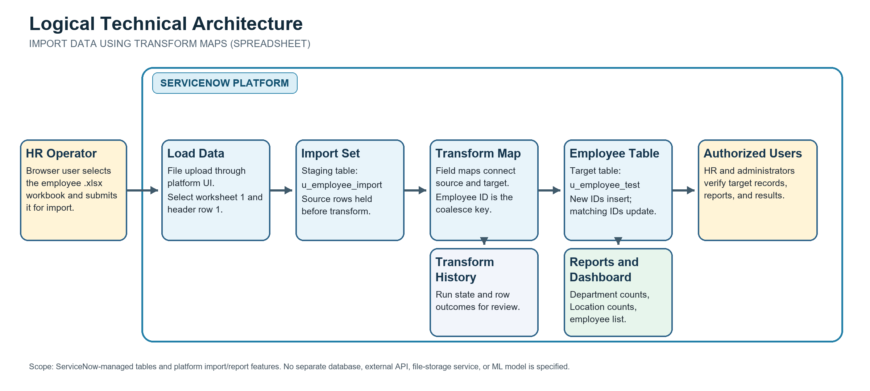
Figure 1. Project architecture and system boundaries.
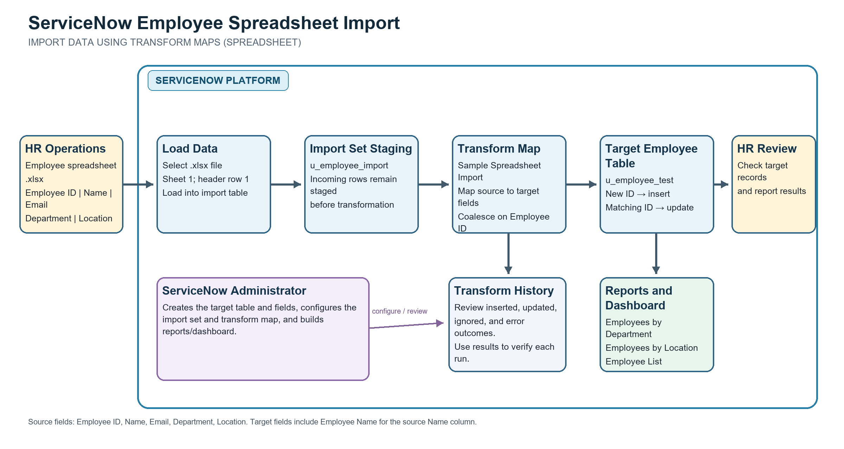
Figure 2. Employee spreadsheet data flow through staging, transform, target, and review.
Component | Project configuration / responsibility
User interface | Authorized coordinator or administrator uses ServiceNow Load Data, transform, tables, reports, and dashboard.
Staging | Employee Import, technical name u_employee_import; temporary/import-set rows.
Transformation | Sample Spreadsheet Import Transform Map maps source columns to target fields.
Target | Employee Test, technical name u_employee_test; five string fields.
Match behavior | Employee ID is the coalesce field; a match updates, no match inserts.
Verification | Transform History, Employee Test list, aggregate reports and dashboard.

4. Data Model and Field Mapping
Source column | Target field | Type | Rule
Employee ID | Employee ID | String | Required operationally; coalesce key; unique in target.
Name | Employee Name | String | Explicit mapping; source and target labels differ.
Email | Email | String | Direct field map.
Department | Department | String | Direct field map.
Location | Location | String | Direct field map.
The implementation guide indicates Auto Map Matching Fields followed by Mapping Assist. The saved map must be checked to ensure all five pairs above exist and Employee ID coalesce is enabled. Duplicate or blank identifiers can make matching ambiguous and must be corrected before production use.

5. Functional Requirements
ID | Requirement | Acceptance evidence
FR-1 | Create u_employee_test with Employee ID, Employee Name, Email, Department, and Location. | Fields visible on target form/list.
FR-2 | Load .xlsx rows into u_employee_import using worksheet/header selection. | Completed import set and staged row count.
FR-3 | Map five source fields, including Name to Employee Name. | Saved source-to-target field map.
FR-4 | Coalesce on Employee ID; insert new IDs and update matches. | Controlled insert/update test with no duplicate target key.
FR-5 | Run transformation and verify records and outcomes. | Transform History and target-list comparison.
FR-6 | Create requested reports and dashboard. | Three reports and dashboard reviewed with authorized access.

5.1 Non-functional requirements
ID | Requirement | Verification / open criterion
NFR-1 Usability | Repeatable load/transform flow with understandable field names and visible outcome. | Walkthrough by intended coordinator; acceptance pending.
NFR-2 Security | Restrict source files, import/target tables, reports and dashboard to authorized roles. | Review ACLs, role grants, sharing, and negative access tests.
NFR-3 Reliability | Use populated unique Employee ID and retain row-level outcomes. | Negative tests for blank/duplicate IDs and history review.
NFR-4 Performance | Size batches for actual instance and data volume. | Record representative duration; set numeric target with owner.
NFR-5 Availability | Workflow depends on operational ServiceNow instance and assigned access. | No independent SLA supplied.
NFR-6 Scalability | Validate processing time and table growth at expected volume. | Expected volume and load target remain to be agreed.

6. Configuration and Operating Procedure

6.1 Prerequisites
- Approved non-production ServiceNow instance and authorized named account with necessary roles.
- Controlled .xlsx workbook with header row 1: Employee ID, Name, Email, Department, Location; one person per row.
- Review and resolve blank or duplicate Employee IDs before upload. Do not put real employee data in unapproved test environments.

6.2 Configure once
- Create Employee Test (u_employee_test) and the five String fields.
- Load a sample workbook through Load Data to create Employee Import (u_employee_import), or select the existing staging table.
- Create Transform Map named Sample Spreadsheet Import. Set source Employee Import and target Employee Test.
- Auto-map matching labels, then use Mapping Assist for Name to Employee Name. Inspect all saved mappings.
- Enable coalesce for the Employee ID field map. Save and verify the map configuration.
- Create and save Employees by Department (pie/count), Employees by Location (bar/count), and Employee List Report (five fields).
- Create the Employee Analytics dashboard and add the three reports. Confirm the exact dashboard name and access configuration in the instance.

6.3 Each import run
- Select Load Data and choose the .xlsx file. Select existing table u_employee_import, worksheet 1, header row 1.
- Submit and confirm the import set completes; note its row count and identifier.
- Run the Sample Spreadsheet Import transform against that import set.
- Open Transform History; record run identity, insert/update/ignore/failure counts, and errors.
- Compare selected target records and list totals to the source. Investigate exceptions before using reports.
- Use only authorized access when viewing employee details. Retain or delete source files according to organizational policy.

7. Reports and User Interface
Report | Type | Configuration / display
Employees by Department | Pie chart | u_employee_test; group by Department; aggregation Count.
Employees by Location | Bar chart | u_employee_test; group by Location; aggregation Count.
Employee List Report | List | Employee ID, Employee Name, Email, Department, Location.
Employee Analytics Dashboard | Dashboard | Contains the three reports; restrict sharing to intended users/groups/roles.
The source guide alternates between “Employee Analytics Dashboard” and “Employee Analytics Dashboards.” Confirm the actual saved name. Although the walkthrough mentions enabling Admin Override on a pa_dashboards ACL to reach the creation form, changing a base ACL is security-sensitive. Do not apply that workaround without explicit instance security administrator approval; prefer an approved role and least-privilege path.

8. API and Integration
No custom API is part of the documented solution. The implemented interaction is an authorized user uploading a workbook through the ServiceNow interface. The ServiceNow Import Set API is a possible future integration route only; it is not evidence that an API was configured or tested.

9. Authentication and Security
- Use named accounts and least-privilege roles. Confirm table and field ACLs for u_employee_import and u_employee_test.
- Restrict report and dashboard sharing; a dashboard should not expose employee details to unauthorized users.
- Use synthetic or approved test data in non-production. Protect uploaded spreadsheets and exported screenshots.
- Review import permissions, data retention, audit/history access, and any instance-specific privacy requirements with the platform owner.

10. Testing and Evidence
The supplied implementation guide reports successful initial import and describes a later 4-row import with 2 inserted new IDs and 2 updates to matching IDs. It further reports that repeating the same four rows produced 0 inserts, 0 updates, and 4 ignored rows. These are source-reported demonstration outcomes, not independently rerun results or formal acceptance testing.
Evidence item | Documented state
Sample target data | Screenshots show 17 sample records; aggregate screenshot reports show Department counts ServiceNow 11, Salesforce 4, Aiml 2 and Location counts Hyderabad 16, Chennai 1. Sample-data evidence only.
Transform behavior | Guide reports 2 inserts + 2 updates on a four-row mixed batch; repeat: 0 inserts + 0 updates + 4 ignored.
Formal UAT | 17 planned functional/security cases are Not run; tester, instance URL, actual results, and sign-off are pending.
Performance | No measured duration, volume threshold, or numeric service target supplied.
The reports are supported by aggregate-only screenshots; no individual employee list is embedded to avoid unnecessary disclosure of names and email addresses.
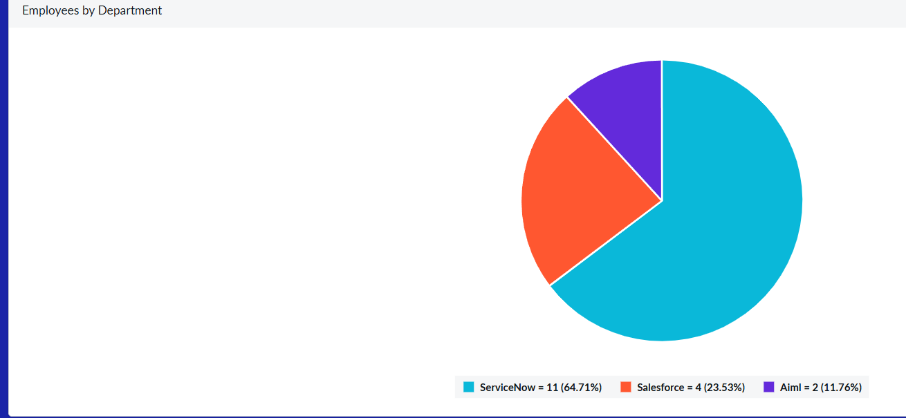
Figure 3. Aggregate sample-data employee counts by department.
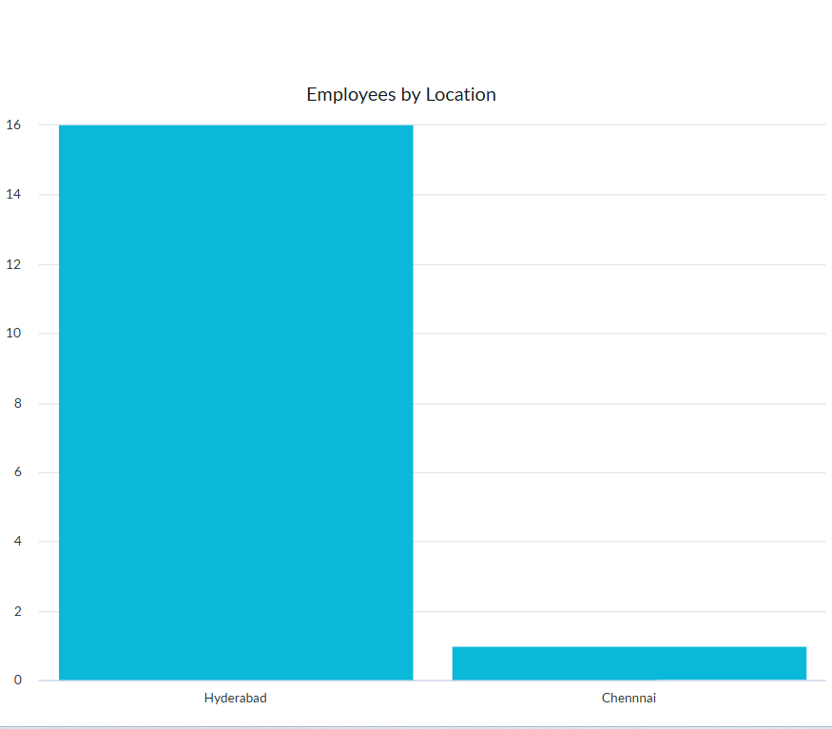
Figure 4. Aggregate sample-data employee counts by location.

11. Known Issues and Decisions to Confirm
- The source guide does not explicitly show the saved field-map configuration or a formal test log; verify in the instance.
- Confirm dashboard singular/plural name and dashboard/report sharing.
- Confirm whether only the three detailed reports are implemented. The guide conclusion mentions additional total/new/updated/import success/error metrics without configuration steps; treat those as unverified.
- The ACL Admin Override workaround needs security-owner review.
- Confirm source workbook schema, unique-ID policy, expected data volume, retention, supported ServiceNow release, and deployment ownership.

12. Future Enhancements
- Add pre-transform validation for blank/duplicate Employee IDs and required headers with actionable feedback.
- Define a controlled error-correction and reprocessing process.
- Capture import duration, batch size, and error rates to set measurable performance goals.
- Consider an approved API-based feed or scheduled import only if a future requirement justifies it.
- Add validated summary metrics only after implementing and reconciling them against Transform History.

13. References and Related Project Artifacts
- Project implementation guide: “Import Data using Transform Maps (Spreadsheet)” supplied by the project owner.
- Project requirements: Solution Requirements - SWTID-2026-8585; 6 functional and 6 non-functional requirements.
- Design: Data Flow Diagram and User Stories; Technology Stack and Architecture; Solution Architecture.
- Testing: Functional and Performance Testing; UAT Plan - SWTID-2026-8585.
- ServiceNow Import Sets key concepts: https://www.servicenow.com/docs/r/xanadu/integrate-applications/system-import-sets/c_ImportSetsKeyConcepts.html
- ServiceNow create a field map and coalesce: https://www.servicenow.com/docs/r/integrate-applications/system-import-sets/t_CreatingAFieldMap.html
- ServiceNow ACL rule types: https://www.servicenow.com/docs/r/platform-security/access-control/acl-rule-types.html

